**Aufgabenbeispiel**

**Semester 1, 2. Quartal**

***Eating habits***

***Eating habits*, Semester 1, 2. Quartal, Einheit 1**

**1. 🗣 Speaking – *Typical food***

*Many people in different countries pride themselves for certain popular dishes. People from other countries, however, think they know what “is typically British, Italian, German” … What about you?*

Work in small groups of four people.

1. On your own: Think of food that is typical for a country. Write your ideas down in your part of the placemat.

2. Exchange your ideas with the partners of your group and discuss the questions of document 2. Note down common ideas in the middle field of the placemat.

3. Present these ideas to the rest of the class.

**📋Doc 2 -** **Discussion Questions**

**Things to discuss**

* What kind of food do you like / do you dislike?
* What are your eating habits?
  + when you are busy,
  + at weekends / during holidays,
  + when / what / where do you eat?
* What does cooking mean to you?

**📋Doc 1 - Placemat**

|  |  |  |  |
| --- | --- | --- | --- |
|  | |  | |
|  |  | |  |
|  |  |
|  | |  | |

**2. 🗣 Speaking – *Eating out?***

1. Read the following questions.

2. Talk about theses questions to your partner.

|  |  |
| --- | --- |
| Do you like to eat out? Why? Why not? | What’s your favorite restaurant? Where is it? |
| Why do you like that restaurant? | How often do you go there? |
| Who do you usually go with? | What’s your favourite item on the menu? |
| What’s the atmosphere like? | What’s the service like? |
| What recipes can you cook? | Do you prefer cooking for yourself or going to a restaurant? |

3. Have a look at the following pictures (📋 doc 2). Choose one picture that you either

- identify with.

- like best.

- find annoying.

- …

4. You will have to talk about this picture to your partner. Take 5 minutes to prepare what you want to say. Talk about the following aspects:

- your feelings

- reasons for the situation

- plans

- …

**📋 Doc 2 – Eating out?**

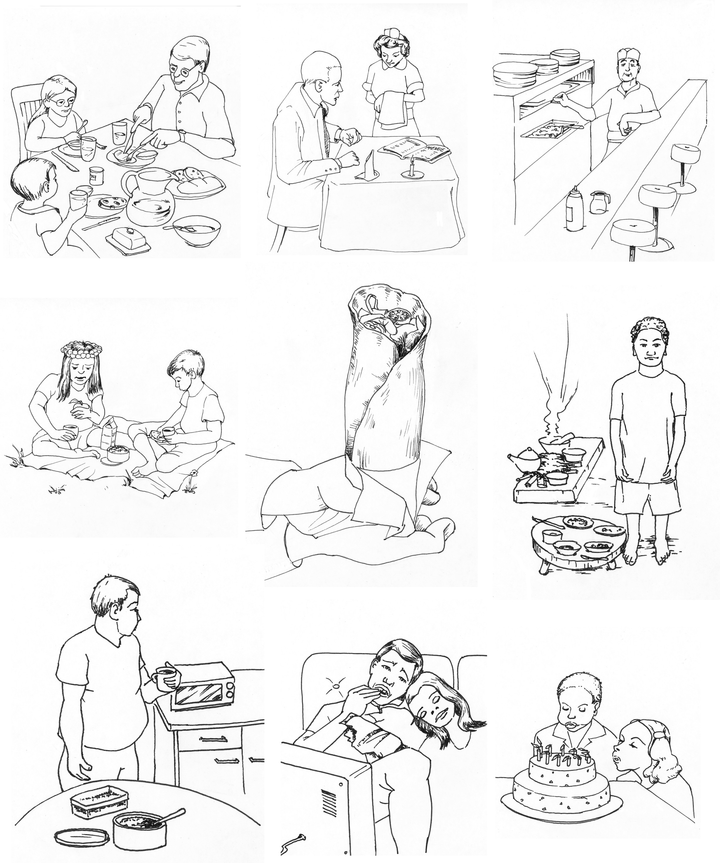

**3.** **🕮 Reading comprehension – *Choosing a restaurant***

*There are a huge number of very different types of restaurants. The lifestyle magazine “British Inn” presents some of the most popular restaurants.*

1. Read the following texts about restaurants.

British Inn, p.22 British Inn, p.22



|  |  |
| --- | --- |
| **Rock and Sole Plaice**  If you fancy nice fish and chips this place is a must! It is popular with locals and tourists all day long. Enjoy traditional fish cakes, cod and haddock in a friendly atmosphere.  Food is also served outside under trees lit by strings of lights which makes this place a good choice for a summer evening. The prices are reasonable, families are welcome.  **The Crypt**  Only a stone’s throw from the National Gallery and Whitehall this place is located underneath the church St Martin-in-the-Fields. It’s a self-service restaurant with a menu offering a small choice of simple but tasty dishes at reasonable prices also for vegetarians. Tables are arranged between huge solid stone columns so this is an atmospheric experience you wouldn’t find anywhere else.  **Food For Thought**  This small but colourful restaurant and takeaway dishes out a daily changing menu. There is a great diversity of vegetables, fresh herbs and spices and the meals are free of meat and additives. As queues are long at lunch, you’ll have to share a table if you eat in. But this experience brings many customers back time and again.  **The White Hare**  This lovely cosy pub with historic interior was established in 1656. On Saturday afternoons it may be busy inside, but it won’t be crowded or noisy and you will soon find a free table. Traditional English food is served by friendly and attentive staff. | The service is quick and friendly at the bar. What’s more, there is a fine range of English beers and ales.  **Tandoori Garden**  This family owned traditional house in London’s West End opened in 1975. We are fully licensed, air-conditioned and serve great favourites such as chicken rezala and lamb lemon grass. There are many dishes to choose from as well as some set meals. We have 180 seats and offer a pulsating atmosphere especially at weekends. We also have a special room for great parties. Friendly staff and unforgettable food make this location the place to go for a spicy night out.  **The Ritz**  This fantastic palace-style dining room is one of London’s most famous restaurants, and not only because Julia Roberts used to dine here in the film “Notting Hill”. Tail-coated and extremely polite waiters, discreet live music, shiny glass and silver make this place popular with wealthy tourists and “VIPs”.  The prices are impressive, with starters and main courses from £25 to £56 and desserts up to £48 for two! But dining here is a grand and glitzy event you will never forget.  **The Hard Rock Café**  It’s the first ever theme restaurant and a genuine celebration of rock ‘n’ roll as well as a tourist attraction. There will always be a queue outside, all day long and almost every day of the year. But this actually belongs to the experience you will get in this outstanding restaurant. There is a variety of fine burgers to choose from and the famous nachos are as huge and cheesy as their reputation. Rock music blasts at high levels and the walls are covered with guitars and other rock music souvenirs. |

Bild: http://imagers.gsfc.nasa.gov/ems/OS06097.JPG

2. During the holidays you have a work placement at a London tourist information centre. There are several visitors (texts A - G) who want to find a good restaurant. Read through the following texts (texts A - G) and decide which address you give to the tourists (texts A – G).

|  |  |  |
| --- | --- | --- |
| **Texts** | **Your tip:** | |
| **A - Jenny and Marc from Oxford**  They love music and fast food. They have lots of time and are ready to wait for a free table. | The Ritz  150 Picadilly  Tel: 020 7493 8181 | ⬜ |
| **B - Mrs. Carol Potter from Plymouth**  She prefers extraordinary atmosphere but also reasonable prices. So she is happy with a limited choice of tasty dishes on the menu. | Rock and Sole Plaice  47 Endell Street, Covent Garden,  Tel: 020 7836 3785 | ⬜ |
| **C - Vivien and her friend Sarah from New York**  They are vegetarians and want to get to know other people. They prefer dishes without artificial ingredients. | The Crypt  6 St Martin’s Place  London  Tel: 020 7839 4342 | ⬜ |
| **D - Madame and Monsieur Moaté from Paris**  They love exquisite food and want to eat in an elegant atmosphere. Money doesn’t matter. | The White Hare  34 Tottenham Court Road  Tel: 020 7654 3587 | ⬜ |
| **E - The deWinter family from the Netherlands**  The family with their three children want to learn more about typically British food. Since the weather is nice, they would enjoy eating outside. | Food For Thought  31 Neal Street  Covent Garden,  Tel: 020 7836 9072 | ⬜ |
| **F - Mr. and Mrs. McNeal from Scotland**  The elderly couple prefers restaurants in historical buildings. They like traditional British food. Mr. McNeal sometimes fancies a beer at the bar. | The Hard Rock Café  Piccadilly Arcade, City of Westminster  Tel: 020 7514 1700 | ⬜ |
| **G - William and Kate from London**  They would like to celebrate their wedding together with 65 guests. So they are looking for a restaurant for their party. They like spicy and exotic food. | Tandoori Garden  98 Lillie Road  Greater London  Tel: 020 7381 1069 | ⬜ |

3. **Optional task:** What about you? Which of these restaurants do you like best? Explain why and exchange with a partner.

Useful phrases

I recommend/I would recommend … because it’s …

because it has got …

because there is/are …

**Strategy – How to deal with an English text**

4. Exchange with a partner:



- Which difficulties did you have in understanding the text?

- With your partner, think about strategies that can help to understand an English text.

- Write down your difficulties and your strategies (📋 doc. 3). If it is easier for you, you can do so in German.

**📋 Doc 3 – Reading comprehension: *How to deal with an English text***

|  |  |
| --- | --- |
| **Difficulties I had while reading …** | **This is what I can do to make reading comprehension easier …** |
|  |  |

**4. 👂Listening comprehension – *Ordering lunch and dinner***

*Mr. and Mrs. Bloom want to spend a nice evening out. They decide to eat out in a new restaurant.*

You are going to listen to their conversation in an English restaurant.

1. Look at the pictures.

2. Then listen to the dialogue.

3. What do Mr. and Mrs. Bloom order? Tick the correct items. There is one more item than you need.

|  |  |  |  |  |  |  |  |  |  |
| --- | --- | --- | --- | --- | --- | --- | --- | --- | --- |
|  |  |  |  |  |  |  |  |  |  |
| Mr. Bloom |  |  |  |  |  |  |  |  |  |
| Mrs. Bloom |  |  |  |  |  |  |  |  |  |

**5. Working on language**



*On holiday, most people use English because they do not speak the language of the country.*

1. Read the transcript of the restaurant scene (**📋**Doc.4) and concentrate on expressions you need when ordering food in a restaurant.

2. Underline phrases and expressions for “eating out” and create a list.

3. What other expressions might be useful? Complete your personal “list” of useful expressions for “eating out”.

**6. 🗣 Speaking** – ***Eating out***

*Now, practice using the expressions from the exercise above.*

1. Work with a partner.

2. Choose your role (A or B) and fold the sheet along the middle line.

3. Read your side of the sheet.

4. Do the dialogue with your partner. You can help him/her if there is a problem. **Mind**: You are **not** supposed to translate the German sentences into English. Just bring across the message and use the expressions from the exercise above.

|  |  |
| --- | --- |
| **Partner A** | **Partner B** |
| **Sprechen Sie B freundlich an und fragen Sie ihn, ob er etwas bestellen möchte.** | *Are you ready to order, sir?* |
| *Yes. I´ll have the Chicken Paté for starters and my wife would like the tomato soup.* | **Bejahen Sie die Frage und bestellen Sie Hühnchenpastete als Vorspeise und für Ihre Frau eine Tomatensuppe.** |
| **Wiederholen Sie die Bestellung und Fragen Sie die Gäste, was sie als Hauptgericht möchten.** | *One paté and one tomato soup. What would you like for the main course?* |
| *I´ll have the grilled Pork with chips and my wife would like the breaded haddock with mashed potatoes.* | **Bestellen Sie für sich gegrilltes Schwein mit Pommes und für Ihre Frau den panierten Schellfisch mit Kartoffelpürree.** |
| **Sie bedauern, dass der Fisch ausverkauft ist.** | I´m afraid the haddock is off. |
| *Oh dear. Err... What else do you recommend?* | **Sie sind ein wenig enttäuscht und fragen, was der Kellner Ihnen ansonsten empfehlen kann.** |
| **Sie sagen, dass der Lachs sehr gut ist.** | *The salmon is very good.* |
| *OK. I´ll have that. Do you have any coleslaw?* | **Sie sind einverstanden und fragen, ob es Kohlsalat gibt.** |
| **Sie bedauern, dass es keinen gibt.** | *No, I´m sorry, we don´t.* |
| *Just give me a small green salad then.* | **Sie sagen, dass er Ihnen dann eben einen grünen Salat geben soll.** |
| **Drücken Sie aus, dass Sie diese Bestellung vermerkt haben. Fragen Sie, ob die Gäste etwas trinken möchten.** | *Certainly. Would you like something to drink?* |
| *Yes, please. We would like a bottle of white wine – the house wine, please.* | **Antworten Sie höflich mit “ja” und bestellen Sie eine Flasche von dem weißen Hauswein.** |
| **Drücken Sie aus, dass der Gast eine erstklassige Wahl getroffen hat.** | Excellent choice! |
| Can we get a bottle of water as well? | **Bestellen Sie noch eine Flasche Wasser.** |
| **Fragen Sie, ob mit oder ohne Kohlensäure.** | *With or without gas?* |
| *Without gas, please.* | **Sie möchten Wasser ohne Kohlensäure.** |
| **Drücken Sie aus, dass Sie die Bestellung gerne aufgenommen haben und dass Sie gleich wieder zurück sein werden.** | *You’re welcome. I’ll be back in a minute.* |

**7. 🗣 Speaking - *Ordering food***

*Now it’s your turn: Imagine you are a guest in a British restaurant.*

1. Work in pairs and choose one of the menus below (**📋**Doc. 5 and **📋**Doc. 6).

2. Write down a little role play in which one of you is the waiter/waitress, the other one the guest. Remember to be polite! Your list of expressions may be helpful.

3. Rehearse your role play and then change the roles.

4. Present your role play to the rest of the class.

**📋 Doc. 5 - Menu 1**

|  |  |
| --- | --- |
| **🙗 Ship Inn🙖**  **Starters**  **Mixed Olives with Crusty Bread and Garlic Butter £ 3.40**  **Tomato and Basil Soup £4.35**  **Herb Breaded Mushrooms £4.35 Individual Smoked Salmon Terrine £5.95 Chicken Liver Pâté with Brandy and Garlic £4.35**  **World Famous Pies**  **Served with one of the following: Mashed Potato, Garden Vegetables, Green Salad, Chips, Potatoes or Baked Potato**  **Steak and Mushroom Pie £12.25**  **Fisherman’s Pie £12.25**  **Shepherd’s Pie £12.25**  **Steak and Kidney Pie £12.25**  **Chicken, Mushroom and Leek Pie £12.25**  **Desserts**  **Homemade Ice Creams £4.45**  **Dark Chocolate Pudding with custard**  **£4.55**  **Apple Crumble with almonds and Clotted Cream £4.95** | **🙗 Ship Inn🙖**  **Steaks**  **Char-grilled over hot coals. All Served with a choice of Steak Sauce, Béarnaise Sauce or Garlic Butter**  **8oz Sirloin Steak £14.25 8oz Fillet Steak £17.50**  **Classic Dishes**  **Served with one of the following: Garden Vegetables, Green Salad, Chips, Mashed Potato, Potatoes or Baked Potato**  **Crispy Breaded Haddock Fillets £8.95**  **Salmon & Prawn Fish Cakes £11.95**  **Grilled pork loin with spicy apple sauce £ 12.25**  **Braised Lamb with Mint Sauce £14.95**  **Roast sirloin of beef with Yorkshire pudding £14.95**  **Side Orders**  **Garden Vegetables with Parsley Butter, Green Salad, Chips, Mashed Potato, Potatoes, Baked Potato, Red Cabbage;**  **all £2.95 each Spicy Lentils, Minted Peas; all £1.95 each** |

**📋 Doc. 6 - Menu 2**

**Garlic Bread**

4 pieces of freshly baked French bread with garlic butter and herbs. **£4.75**

**Spin Rolls**

A choice between succulent chicken bits or spinach & feta

Stuffing wrapped in tortilla and served with your favourite dip. **£6.45**

**Salad Bar**

Load up your plate with a bundle of delicious crispy salads

from our famous salad bar. **£3.50**

**Beef Burger with Tomato & Onion Relish and French Fries £6.50**

**Vegetarian Burger £6.50**

Spinach and lentil burger served with roasted red peppers, sliced tomato,

lettuce and mayonnaise, with a salsa dip and chunky chips

**Ravioli with ricotta & Red Peppers £6.95**

Dressed with roasted tomatoes and mushrooms served with a rocket

Garnish

**Fish Finger Sandwich £4.50**

A ciabatta filled with crispy-coated sole nuggets and tartare sauce

**Sausage & Mash**

Cumberland sausages, served on mashed potatoes and covered in onion gravy **small £5.95**

Avegetarian option of carrot, parsnip, onion and herb sausages is also available **large £8.95**

.

**Chocolate Fudge Cake £3.65**

A chocolate sponge cake layered with chocolate fudge filling, coated in

chocolate icing and decorated with brownie pieces and chocolate chips.

**Summer Berry Waffle £3.65**

A warm waffle with frozen berry yoghurt and mixed summer berries

**Vanilla Ice Cream,**

**Caramel & Chocolate Chip Ice Cream**

**or Summer Berry Frozen Yoghurt**

**£2.65**

**8. 🗣 Speaking** – ***Food Proverbs and Quotes***

*There are a huge number of proverbs and quotes that English people are familiar with. In this exercise you will talk to a number of different students about the meaning of these proverbs and quotes.*

Form two circles (one inner circle and one outer circle) and distribute the cards on the chairs of the inner circle. Sit down and make sure every student faces another one. With your partner pick up your card and discuss the proverb/quote with the help of the questions in document 7. Change seats clockwise so that you face another partner. Your teacher will give you a signal when it’s time to change seats.

**📋 Doc. 7 Questions for discussion**

1. What does each proverb/quote mean?
2. Do you agree or disagree with this proverb/quote?
3. What about your own language? Is there a similar saying?

|  |  |  |
| --- | --- | --- |
| **An apple a day keeps the doctor away.**  *Proverb* | **You are what you eat.**  *Proverb* | **Kissing doesn’t last: cookery does.**  *George Meredith*, British novelist (1828-1909). |
| **One cannot think well, love well, sleep well, if one has not dined well.**  *Virginia Woolf,* British novelist (1882-1941) | **There is no such thing as a little garlic.**  *Proverb* | **A smiling face is half the meal.**  *Proverb* |
| **There is no sincerer love than the love of food.**  *George Bernard Shaw*, British writer (1856-1950) | **Man cannot live by bread alone**  *Proverb* | **Training is everything.  The peach was once a bitter almond; cauliflower is nothing but cabbage with a college education.**  (*Mark Twain,* American author and humorist (1835-1920)) |
| **In general, mankind, since the improvement in cookery, eats twice as much as nature requires.**  *Benjamin Franklin,* one of he founding fathers of he US (1706-1790) | **As a child my family's menu consisted of two choices: take it or leave it.**  *Buddy Hackett,* American comedian and actor (1924-2003) | **A hungry man is an angry man**  *Proverb* |

**9. Evaluation**

*After**having completed this unit, fill in the following grid for your Learner’s portfolio. What else have you learned or need to learn? Write it down.*

|  |  |  |  |
| --- | --- | --- | --- |
| After having completed this unit I can... | **☺** | **😐** | **☹** |
| ... talk about eating habits |  |  |  |
| ... talk about different kinds of restaurants in London |  |  |  |
| ... read and understand a menu with typical British dishes |  |  |  |
| ... order a menu in a restaurant |  |  |  |
| ... understand and discuss some English food quotes and proverbs |  |  |  |
| … |  |  |  |
| … |  |  |  |

**Anhang**

**Lösungen**

**3.** **🕮 Reading comprehension – *Choosing a restaurant***

|  |  |  |
| --- | --- | --- |
|  |  |  |
| **A - Jenny and Marc from Oxford**  They love music and fast food. They have lots of time and are ready to wait for a free table. | The Ritz  150 Picadilly  Tel: 020 7493 8181 | D |
| **B - Mrs. Carol Potter from Plymouth**  She prefers extraordinary atmosphere but also reasonable prices. So she is happy with a limited choice of tasty dishes on the menu. | Rock and Sole Plaice  47 Endell Street, Covent Garden,  Tel: 020 7836 3785 | E |
| **C - Vivien and her friend Sarah from New York**  They are vegetarians and want to get to know other people. They prefer dishes without artificial ingredients. | The Crypt  6 St Martin’s Place  London  Tel: 020 7839 4342 | B |
| **D - Madame and Monsieur Moaté from Paris**  They love exquisite food and want to eat in an elegant atmosphere. Money doesn’t matter. | The White Hare  34 Tottenham Court Road  Tel: 020 7654 3587 | F |
| **E - The deWinter family from the Netherlands**  The family with their three children want to learn more about typically British food. Since the weather is nice, they would enjoy eating outside. | Food For Thought  31 Neal Street  Covent Garden,  Tel: 020 7836 9072 | C |
| **F - Mr. and Mrs. McNeal from Scotland**  The elderly couple prefers restaurants in historical buildings. They like traditional British food. Mr. McNeal sometimes fancies a beer at the bar. | The Hard Rock Café  Piccadilly Arcade, City of Westminster  Tel: 020 7514 1700 | A |
| **G - William and Kate from London**  They would like to celebrate their wedding together with 65 guests. So they are looking for a restaurant for their party. They like spicy and exotic food. | Tandoori Garden  98 Lillie Road  Greater London  Tel: 020 7381 1069 | G |

**Transkript**

**4. 👂Listening comprehension – *Ordering lunch and dinner***

|  |  |
| --- | --- |
| Waiter:  Mr Bloom:  Waiter:  Mr Bloom:  Waiter:  Mrs Bloom:  Waiter:  Mrs Bloom:  Waiter:  Mrs Bloom:  Mr Bloom:  Waiter:  Mr Bloom:  Waiter:  Mrs Bloom :  Waiter:  Mrs Bloom:  Waiter: | Are you ready to order, sir?  Yes. I’ll have the baked potato for starters and my wife would like the tomato soup.  One pâté and one tomato soup. What would you like for the main course?  I’ll have the grilled chicken with chips and my wife would like the sausages with mashed potatoes.  I’m afraid the sausages are out.  Oh dear. Err... What else do you recommend?  The salmon is very good.  OK. I’ll have that. Do you have any mushroom salad?  No, I’m sorry, we don’t.  Just give me a small green salad then.  Same for me, please.  Certainly. Would you like something to drink?  Yes, please. I would like a glass of white wine – the house wine, please.  Excellent choice!  Can I get a bottle of water?  With or without gas?  Without gas, please.  You’re welcome. I’ll be back in a minute. |