M1 Teacher’s sheet: Lead-in

Welcome to the castle!

Hello everybody,
welcome to my castle! I’m the pet dragon and want to tell you more about life in my castle. Oh, it isn’t my castle and I’m not the only one who lives in this castle. The most important people are the King and the Queen with their daughter, Princess Fifi. They are very busy, so Bella and Jack work for them. My secret friend is the cook who can do the best peppermint cream you can imagine! Then there is Wizard Watchit. His hobby is to do magic in the castle. But often the spells go wrong, which can be very funny!
Every morning Bella wakes me up. I can sleep for ages in my tiny cupboard. When I am awake, Bella carries me around with her, under one arm, because well, I am quite small for a dragon. Then I make a fire in every room of the castle. This is a lot of work and makes me very hungry. Our last stop is the kitchen where I always try to get something to eat – but this is my secret.
Our mornings always start like this – but today everything is different…

M2 Worksheet: A dragon profile

Wanted! A profile of my pet dragon

Our story is about a pet dragon. What do you think he/she will be like?

- Label the picture of the dragon. Use the words below.

arm – ear – eye – foot – hair – claw – head – knee – toe – razor-sharp teeth – tongue – wings – mouth – stomach – shoulder – leg – nose – tail – spots – spiky scales – flames

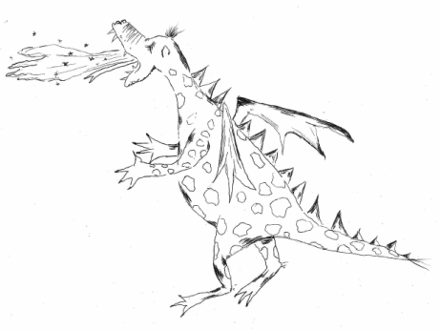

- Complete the profile of your pet dragon.

My name:

Where I was born:

When I was born:

This is how old I am at this moment:

What I look like:

My favourite food:

My special power:

My best friend says I am …

The funniest thing I have ever done:

My silly hobbies are:

My best-kept secret is:

What I do if I get bored:

What stops me from sleeping at night:

My idol is:

If I were the king, I would …

- Tell your neighbour about your dragon.
M3 Reading

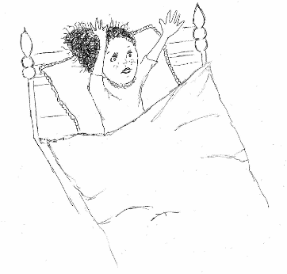
"Dragon!" she cried. "Wake up!"
But there was no dragon in the cupboard. She put her head inside to make sure. The cupboard was empty.
"Oh dear!" said Bella. "Where's that dragon gone?"
She hurried off to find Jack the servant boy. He was busy cleaning the King's boots.
"Jack? Have you got the dragon?" she asked.
"No," said Jack. "Why?"
"It's run off! We've got to find it!" said Bella. "Where can it be?"
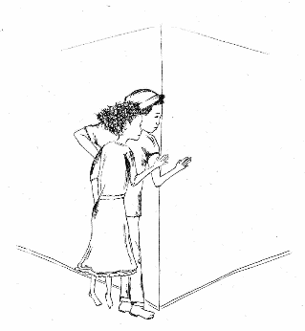
"I expect it's gone looking for something to eat," said Jack. "It's a hungry little dragon. Let's go and check in the kitchen."
So together they began to hunt through the three hundred dusty rooms of Custard Castle.
Bella called out, "Dragon! Where are you?" Jack whistled, but the dragon did not appear.
They both went quietly up the stairs. They tiptoed along the corridor, and put their heads around the corner.
They saw the doors of all the royal bedrooms. They were all closed. But something was rumbling and making a lot of noise in the corridor. Something big and green, with wide, wide wings and a long, long tail.
"It can't be!" gasped Bella.
"It is," said Jack. "That's our dragon."
"But it's enormous!" whispered Bella. "Whatever can have happened?"
The dragon began to rampage up and down the corridor, banging around with its huge scaly feet and flapping its wings.
It wasn’t happy at all. It shattered a vase with its tail. It had already broken a window and a mirror, and knocked four pictures off the wall.
Just then the King came storming out of his bedroom. He was wearing a nightshirt with little gold crowns on it. He looked almost as angry as the dragon.
"What's all this noise? I'm trying to sleep!' he shouted.
Then he saw the dragon – and the dragon saw him. It opened its mouth and huffed red flames.
The King jumped backwards. "Help!" he screamed.
The Queen came running out of the bathroom. She was wearing pyjamas with pictures of tiny hammers.
"What's all-" she began, and then she saw the dragon.
She jumped backwards too. "Help!" she screamed.
Bella and Jack ran towards her. At the same time, Princess Fifi came rushing out of her bedroom. "What's- help!" she screamed. "A dragon! Save me!"
"Someone must have put a spell on it to make it grow," said Fifi. "Like my giant frog prince."
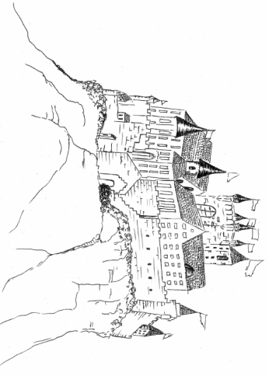
"A spell? Then I know what's happened. It's that stupid Wizard!" said the King. "He's always doing things like this."
The King stomped over to the window. He put his head out and shouted at the tallest tower. "Wizard Watchit! Are you awake?"
The Wizard appeared in the highest window of the tower.
"I am now," he shouted back. "What is it?"
"I want a word with you!" the King shouted. "You come here this minute!"
The Wizard disappeared from his window. A minute later, they heard footsteps running in the corridor outside.
Then they heard a wild banging on the door.
"Help!" said the Wizard's voice. "Let me in! There's a dragon trying to burn me up!"
Jack opened the door and the Wizard shot inside.
"Phew!" he said. "That was a near thing. Where did that dragon come from?"
The King glared at him. "That's our dragon! You must have put a spell on it to make it grow!" he said.
"No, I didn't," said the Wizard.
"It was the right size yesterday! I expect you magicked it by accident."
"No, I-" Wizard Watchit stopped. He just remembered that he always practiced a new spell to turn a pen into a donut. It never worked on the pen, but maybe that was why the dragon …
"You'd better go out there and magic it right back!" the King said to him angrily.
Wizard Watchit gulped. He wished it was a giant donut waiting outside the door, instead of an angry dragon. "I'm afraid I don't know how," he said …

M4 Worksheet: Core skills

Reading comprehension and pronunciation
- Understanding the text:
  - Read the text and tick the correct answer.
  - Give the line numbers where you found your answers.
 | true | false | line number(s)
1. Bella can’t find the dragon because it is with Jack.
2. There are three hundred rooms in the castle.
3. Jack and Bella find the dragon in the kitchen.
4. It’s very big and makes a lot of noise because it is unhappy.
5. The King is scared of the dragon when he sees it.
6. Fifi thinks that the dragon is so big because it ate a magic cake.
7. Wizard Watchit can turn pens into donuts.
8. The Wizard has a great idea how to make the dragon small again.

  - Extra: Correct the false statements into your exercise book.
- Our story doesn’t have a title. Think of a good one and write it into the empty box above the text.
- All the characters in this story are scared of the dragon when it is so enormous and angry. Find words and phrases in the text which show that they are scared.
Example: “It can’t be!” gasped Bella (line 21)

Optional task:
Let’s practice pronunciation: choose the right answers. More than one can be correct.
  - cupboard 1) 'kʌbəd 2) 'kʌpbɔ:d 3) 'kʌbət
  - You can hear a “t” when you say whistle. 1) true 2) false
  - appear rhymes with 1) there 2) here 3) her
  - enormous 1) ɪ'nɔ:məs 2) e'nɔ:məs 3) ɪ'nɔ:mus
  - How many “k”s can you hear when you say knock? 1) one 2) two
  - Wizard sounds like 1) blizzard 2) it’s hard
M5 Worksheet: Word list poem

Now it’s your turn! – Working on your favourite character

Let’s write an ending for the story! Let’s work on the characters first!

- Choose a hero!

Choose one of the characters from the story. This will be your hero. He or she will find a solution.

- What’s your hero like?

- What do you already know about your hero? Take information from the text and the fantasy tour and fill in your findings in the grid below.

- What would you like your character to be like? Think of more words and write them in the grid below. Write down at least 5 more words.

- You can look up the words in the dictionary or in the word box on the back of the page.

What do I already know about my character?  - ______________________________  - ______________________________  - ______________________________  - ______________________________  - ______________________________ | What would I like my character to be like?  - ______________________________  - ______________________________  - ______________________________  - ______________________________  - ______________________________

- Write a poem!

- Use your ideas from the box above and write a poem. List 6 words that describe the character. For the final line, add the character’s name.

Here is an example:

Friendly  Young  Hard-working  Loveable  Magical  Happy  Snow White |  | Your poem:
Word box: List of opposites

clever – stupid | fast – slow | lively – inactive | easy-going – moody
brave – cowardly | hard-working – lazy | friendly – unfriendly | kind – nasty
powerful – weak | crazy – calm | polite – rude | neat – clumsy

M6 Worksheet: Writing

Now it’s your turn – Write your ending to the story!
Let’s go!

Tips how to write an exciting ending to a story
Wow!
Yeah!
Every great story needs a great ending.
These tips can help you to write an exciting ending for the reader:

Action
Hmm…
- Add twists and surprises so that your story is exciting to read.
Characters
- Create a hero that solves the problem.
- Use adjectives to describe your hero.
Oh no!
Dialogue
- Write dialogues to make your story more exciting and livelier.
- Use expressions to show the characters’ feelings (surprise, fear, happiness, …).
I’m scared!
Aaaahr!
Hooray!

- Let’s collect ideas

How does your story go on? Collect ideas in the boxes of the story map (M7).

Need some ideas for an exciting ending? Check the questions on the back of the page!

You have great ideas but need words? Check the useful phrases box on the back of the page!

- Let’s write the first draft

- Follow the structure of your story map.
- Let your hero solve the problem of the enormous dragon.
- Win the final fight against your fire-breathing friend.
- Use the new vocabulary and chunks you have learnt during our project.

- Let’s do a check-up

- Exchange your first draft with your partner.
- Read each other’s stories and fill in the checklist (M8).

- Rewrite your story

- Edit your story with the help of the notes/ideas your partner has given to you. Write your perfect story!

M6 Help: Story map

Some ideas for an exciting ending
These questions can help you to find an exciting ending:

- Will the dragon be small again?
- Will the dragon be his old self again?
- What will your hero do?
- Why is the dragon so enormous?
- What happens to the dragon? Will he have to leave the castle for good?

Answer these questions by taking down notes.

……………………………………………………………………………………………………………………………………………………………………………………………………………………………………………………………………………………………………………………………………………………………………………………………………………………………………………………………………………………………………………………………………………………………………………………………………………………………………………………………………………………………………………………………………………………………………………………………………………………………………………………………………………………………………………………………………………………………………………………………………………………………………………………………………………………………………………………………………………

Some words to make your story sound exciting
English chunk | German translation
(to) cast a spell on something/someone | etwas/jemanden verzaubern
(to) practise a new spell | einen neuen Zaubertrick ausprobieren
(to) escape from someone | jemandem entkommen
(to) make a mistake | einen Fehler machen
(to) grow louder | lauter werden
(to) jump backwards | zurückspringen
(to) work on something | funktionieren
(to) look for someone | jemanden suchen
(to) change one’s size | seine (Körper-)Größe verändern
(to) chase someone | jemanden jagen/verfolgen

M7 Worksheet: Story map
Task: How does the story go on? Collect your ideas in the boxes!
Hooray!
4) Your ideas:

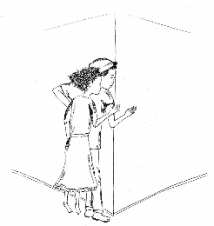
Yeah!
6) Your hero has got the best ideas:

TWIST
2) The dragon is gone! Aaaahr!

Oh no!
5) Why do things have to get so complicated?
7) Ending:

They lived
happily ever after.

3) NOW! The Wizard is coming!
1) The dragon’s
everyday life

Oooooh dear!

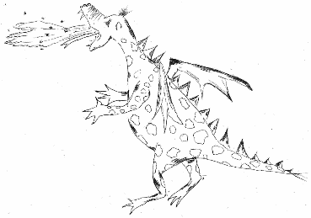

M8 Worksheet: Checklist
Let’s give feedback!

Criteria |  |  |  | Notes / Ideas
Action
- Is there a twist in the story?
- Is the story exciting to read?
Characters
- Can you tell who the hero is?
- Are there adjectives to describe the hero?
Dialogue
- Is there a dialogue?
- Are there expressions of feelings (surprise, fear, happiness, ...)?

I really liked … ___________________________________________________________________________
___________________________________________________________________________
What you could do better: ___________________________________________________________________________
___________________________________________________________________________

Useful phrases for your feedback
- It’s got a catchy title/headline/… .
- I liked the beginning of your story/article/report/…
- I really liked your …
- The idea about … is very good/interesting/funny/original/… .
- The part about … is very exciting/interesting/funny/scary/… .
- The layout looks nice.
- Your writing is neat.
- I think that is a nice picture.
- Maybe you could…

boots – Stiefel
dusty – staubig
(to) whistle – pfeifen
(to) tiptoe – schleichen, auf Zehenspitzen gehen
(to) gasp – keuchen
enormous – hier: riesig, riesengroß
(to) rampage – toben, wüten
(to) huff – schnauben
spell – Zauber
(to) glare – zornig anstarren
(to) gulp – schlucken

