A vet
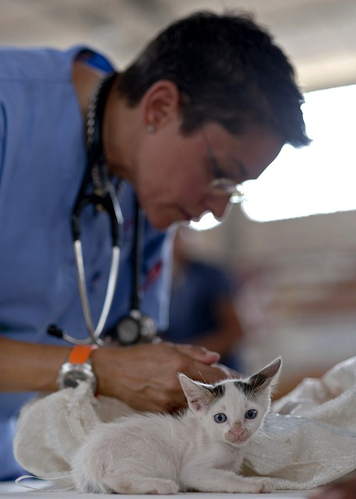

A vet usually works in an animal clinic and has tasks like treating animals and meeting and consulting with animal owners.

Fotoquelle: https://pixabay.com/de/k%C3%A4tzchen-tierarzt-katzen-arzt-pelz-569873/

