A secretary
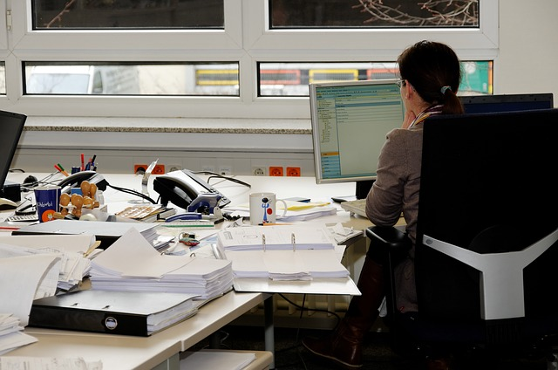

A secretary usually works in an office and has tasks like letter writing or dealing with telephone and email enquiries

Fotoquelle: https://pixabay.com/de/sekret%C3%A4rin-b%C3%BCrojob-b%C3%BCro-office-338561/

